Peak search and determination of orientation matrix

Data for this tutorial are from the oFs100 experiment performed at GSECAS in 2014-2. The DAC used was BX-90 type, with Boehler-Almax diamonds. Crystal C3 is the oFS phase.

Data was collected in small step (1 deg) scan, wide rotations (64 deg) and wide segments (8 deg). Use small step scan for indexing and UB matrix determination, and segments for peak intensity fitting. Wide rotations are also usable for peak intensity, though the statistics is poorer and there is much more special overlap. For this experiment the image setting files (.txt files) have been correctly recorded.

In ATREX 1.0 you can define the omega offset and direction in the “Gonio” tab, as shown below.

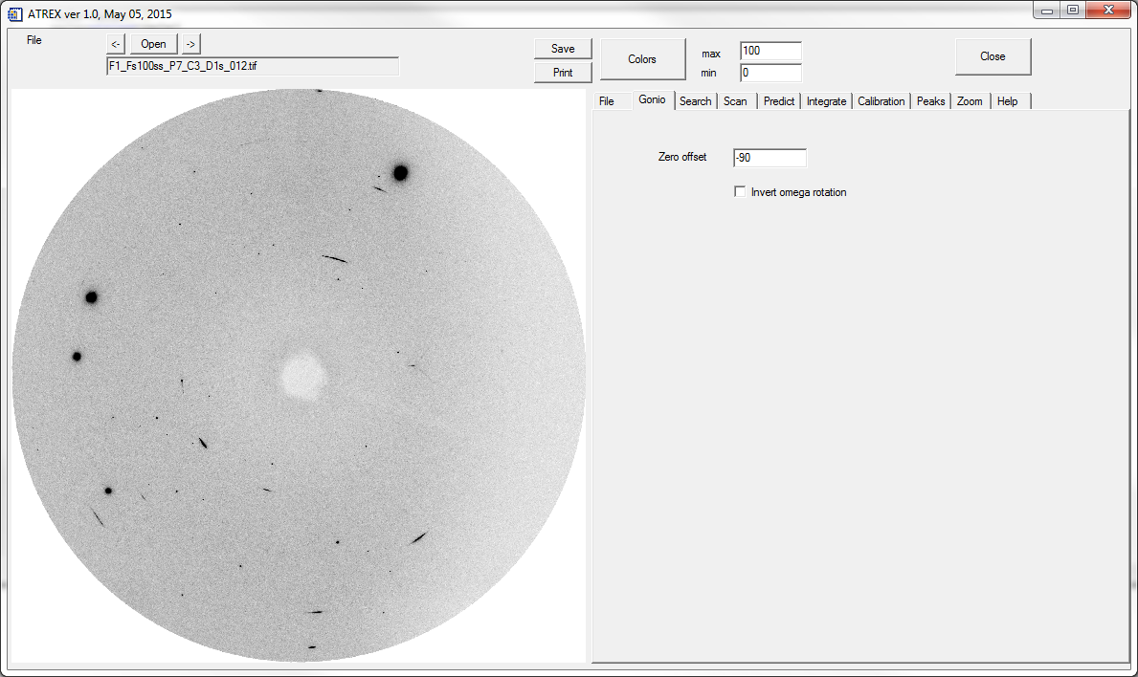

1. Open one of the step scan images
2. Open the corresponding calibration file

ATREX 1.0 reads the setting files corresponding to each image, and fills out the appropriate information in the “Scan” and “Predict” tabs. If no setting files are present you will have to provide the information yourself.

In Search

